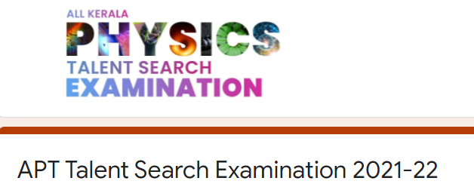

Report on APT Talent search examination 2021-2022 conducted by All Kerala Physics Teachers association

31 students from B.Sc. Applied Physics, KKTM Govt. College registered for the all Kerala Physics Talent Search Examination conducted by All Kerala Physics Teachers Association(APT). 25 students attended the first level online examination held on 26.12.2021 at 10.00 am.

Centre coordinator: DHANYA N P

HOD : LOVELY GEORGE